Eunice Lim

Web 335

Assignment 1.4 – Data Models

19 March 2021

**Object Relational Diagram** 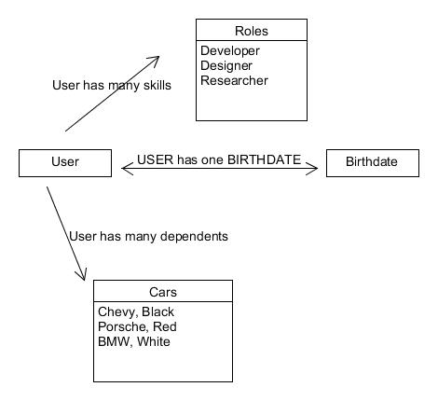

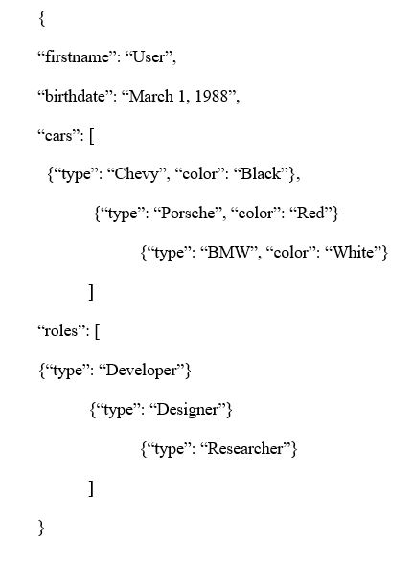**NoSQL data structures**